AQI Analysis-2025
Database creation:
Create database AQI;
use AQI;
Removing the unknown columns from each tables
alter table brasilia_air_quality
drop myunknowncolumn;
alter table cairo_air_quality
drop myunknowncolumn;
alter table dubai_air_quality
drop myunknowncolumn;
alter table london_air_quality
drop myunknowncolumn;
alter table new_york_air_quality
drop myunknowncolumn;
alter table sydney_air_quality
drop myunknowncolumn;
Combine all the table into 1 table
create table air_quality as
select date, city, co, no2, so2, o3, pm25, pm10, aqi from brasilia_air_quality
union all
select date, city, co, no2, so2, o3, pm25, pm10, aqi from cairo_air_quality
union all
select date, city, co, no2, so2, o3, pm25, pm10, aqi from dubai_air_quality
union all
select date, city, co, no2, so2, o3, pm25, pm10, aqi from london_air_quality
union all
select date, city, co, no2, so2, o3, pm25, pm10, aqi from new_york_air_quality
union all
select date, city, co, no2, so2, o3, pm25, pm10, aqi from sydney_air_quality;

Adding a primary key
alter table air_quality
add column serial_no int auto_increment primary key first;
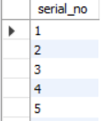
checking correct no of records are imported or not
select count(distinct serial_no) as total_records from air_quality;

select * from air_quality limit 5;

Checking this distinct city
select distinct city from air_quality;
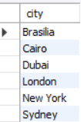
Identify the date range
select min(date) as start_date , max(date) as end_date from air_quality;


Data Cleaning:
Checking presence of missing or null values in the table
select * from air_quality where date is null or
city is null or
co is null or
no2 is null or
so2 is null or
o3 is null or
pm25 is null or
pm10 is null or
aqi is null;
- Null value means no missing values are present.
Changing data type
alter table air_quality
modify date datetime;
alter table air_quality
modify city varchar(10);
Checking duplicates
select count(distinct city, date) as unique_rows
from air_quality;

- No of unique rows is equal to no of total records.
Exploratory Data Analysis (EDA):
Avg aqi by city
select city,round(avg(aqi),2)as avg_aqi from air_quality group by city order by avg_aqi asc;
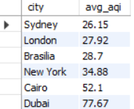
City wise max pollution level
select city,
max(pm25) as max_pm25,
max(pm10) as max_pm10,
max(aqi) as max_aqi
from air_quality group by city order by max_pm25,
max_pm10,
max_aqi;
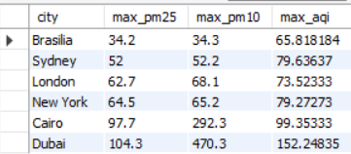
Day wise avg aqi analyse
select date(date) as day, round(avg(aqi),2) as avg_aqi from air_quality group by day order by day;
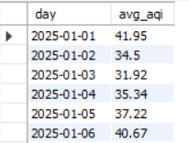
Creating new column and updating with value
alter table air_quality
add column aqi_category varchar(15);
update air_quality
set aqi_category=
case
when aqi <= 50 then 'good'
when aqi <= 100 then 'moderate'
else 'poor'
end;
select distinct aqi_category from air_quality;

Analysis between pm10 vs pm25vs aqi category (max pm10, pm25 then max is aqi)
select aqi_category, round(avg(pm10),2)as avg_pm10,round(avg(pm25),2)as avg_pm25 from air_quality group by aqi_category order by avg_pm10 desc,avg_pm25 desc;
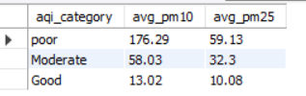
- Pm10, pm2.5 are direct proportional to AQI.
- Pm (Particulate Matter)
PM10 - Particles with diameter ≤ 10 micrometers
Includes dust, pollen, smoke
Can enter nose and throat
Causes breathing irritation
PM2.5 - Particles with diameter ≤ 2.5 micrometers
Comes from vehicle emissions, factories, burning fuels
Can penetrate deep into lungs and bloodstream
Most dangerous pollutant
Which Pollutant affect the AQI more
select
city,
round(avg(pm25),2) as avg_pm25,
round(avg(pm10),2) as avg_pm10,
round(avg(aqi),2) as avg_aqi
from air_quality
group by city
having avg(pm25) > avg(pm10) * 0.3
order by avg_aqi desc;
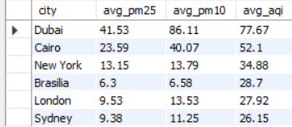
- It shows that PM2.5 affect AQI more as compared to PM10.

